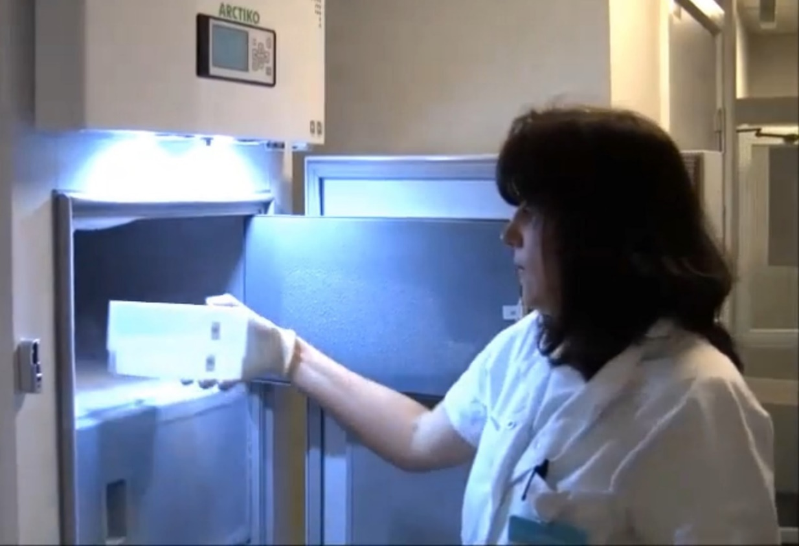

**Biographical sketch**

Dorina Gabriela Amariei (Karottki) graduated as a Biochemist from the Babeș-Bolyai University, Cluj, Romania (June 2003). Afterwards, she came to Copenhagen where she did a Master's degree in Biochemistry at the Faculty of Science (February 2008). Then she followed an epidemiological Ph.D. about “Cardiovascular and respiratory health effects of exposure to particulate matter in non-smoking residents of Copenhagen” at the Department of Public Health, Faculty of Health and Medical Sciences, University of Copenhagen (April 2014) and continued with a short postdoctoral employment at the same place. In 2015, she was employed as Laboratory project manager on a pilot project for establishing the national Danish Rheuma Biobank at the Clinical Biochemistry Department, Rigshospitalet. From 2016, she was employed by the Ministry of Employment, first as a postdoctoral fellow on a research project about Labor market affiliation for people with an occupational injury case - at the Surveillance and Epidemiology Department, National Research Center for Occupational Health, and later as an academic employee working with survey data from the national questionnaire: “Working environment and health” and with registered data about occupational diseases, at the Danish Working Environment Authority.

From April 2022, she works as a Biochemist at the Clinical Biochemistry Department, Hillerød Hospital.

<http://orcid.org/0000-0001-9252-9726>

<https://www.linkedin.com/in/dorina-gabriela-amariei-karottki-72b8713a/>

[dorinagaby@gmail.com](mailto:dorinagaby@gmail.com)